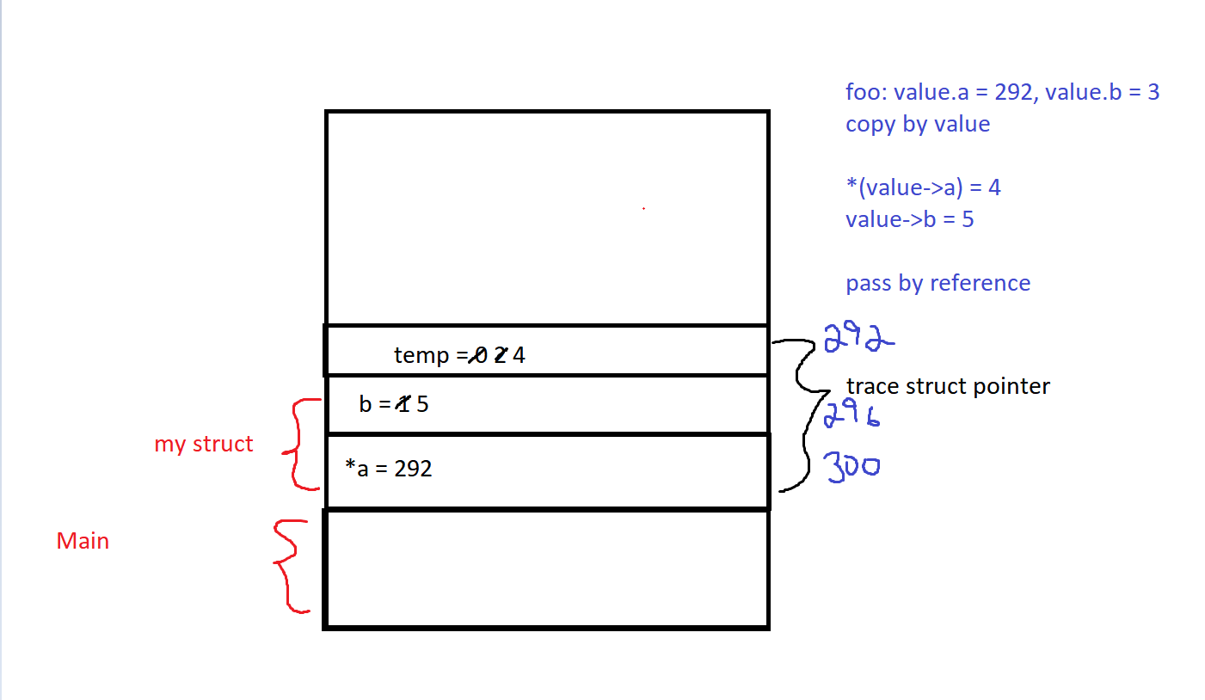

There is a segmentation error because we are attempting to access memory we shouldn’t aka, a variable that is in read only being attempted to be changed.